Scripting Task

Step1:

We need to create one nano file.sh for creating the script inside that written some logic for trying to reach the HTTP server using Guvi.in

Screenshot mentioned below:



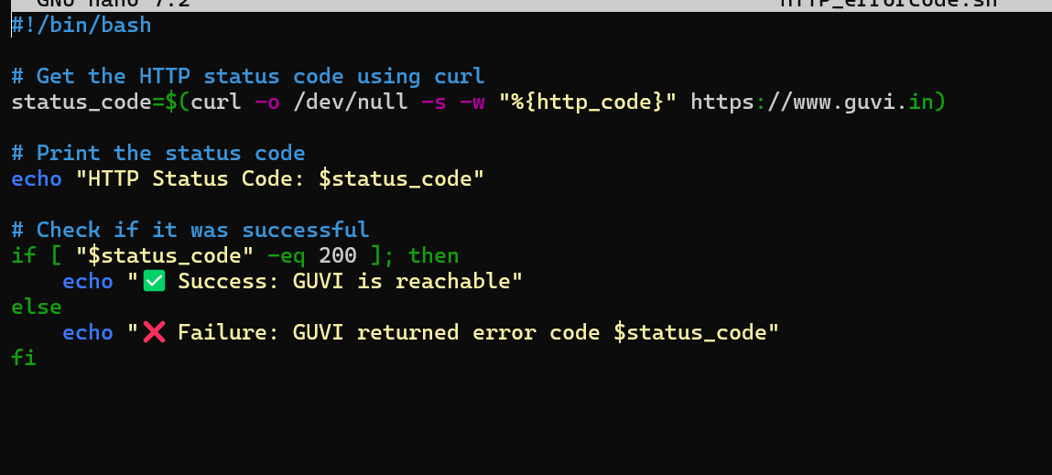

Step 2:

After that we run that script using command ./file_name.sh

It able to reach the server

Screenshot mentioned below:

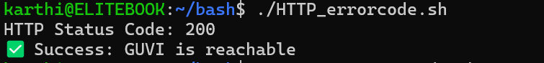

So if make some changes of status code using google or something error code is 302 this for reference

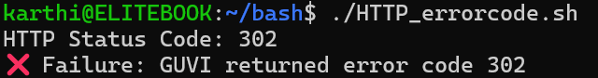

Step 3:

I created one sample.txt file and inside have some content based on the requirement after that created on e.sh file for executing that

Screenshot mentioned below:

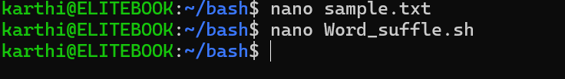

Inside the sample.txt

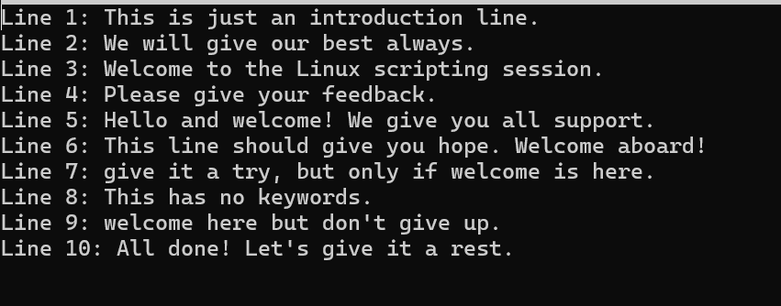

Inside the .sh file is

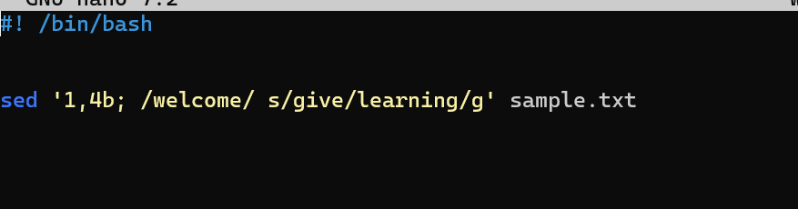

Using this command iam going to suffle all the give to learning from the 5th line till the Welcome word

Screenshot Mentioned below:

Final optput is this after executing the script

